Zoe – BookinfoJacqueline
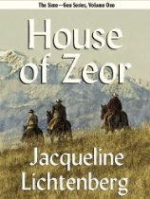
House of Zeor by Jacqueline Lichtenberg. Book One.
Hugh Valleroy of the Gen Police undertakes a covert mission into Sime Territory to rescue the woman he loves from the Sime kidnappers who would use her to destroy his government. His protector and guide? A Sime who carefully and deliberately plans to kill him! http://astore.amazon.com/simegen-20

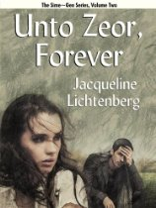
Unto Zeor Forever by Jacqueline Lichtenberg. Book Two.
Digen Farris, Head of legendary House of Zeor; Sime healer, goes into Gen Territory to become a doctor by Gen law. His love with a Gen woman, who is not what she seems, lures him to choose between his Sime heritage and his Gen love that will shape humanity's destiny. http://astore.amazon.com/simegen-20

First Channel by Jean Lorrah. Book Three.
Rimon Farris, a Sime, waits to marry his childhood sweetheart, Kadi. But Kadi turns Gen, no longer human, a thing to be killed. They refuse to accept their fate, fleeing to a strange hybrid community where they try to live together. Will they succeed or will all be lost. http://astore.amazon.com/simegen-20

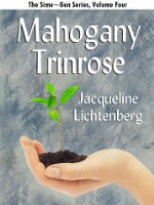
Mahogany Trinrose by Jacqueline Lichtenberg. Book Four.

Digen's only child, Ercy Farris, is about to Changeover , pathologically late for a Farris Channel. Her pet project, growing Mahogany Trinroses, and her dream, distilling kerduvon from the flowers, a mythical drug that can disjunct even a Farris Channel. What fate awaits Ercy, and can love truly conquer all? http://astore.amazon.com/simegen-20

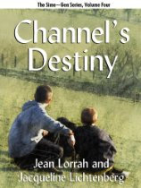
Channel’s Destiny by Jean Lorrah and Jacqueline Book Five.
Zeth Farris, son of a Sime, Rimon, and a Gen, Kadi, reaches adulthood just as war threatens, Zeth must build bridges with potential allies for peace among Simes and Gens to prevail. The price of failure? The destruction of his family, his culture, even his world! http://astore.amazon.com/simegen-20

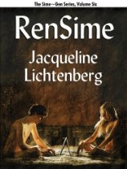
ReSime by Jacqueline Lichtenberg. Book Six.

Laneff Farris believed that she had not inherited the special talents of the Farris mutation. She is swept into an underworld where lines between Science and Magic blur. Which of two men should she follow? Should she forge a completely new direction, and take the rest of humanity with her? http://astore.amazon.com/simegen-20

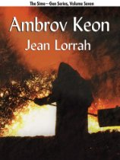
Ambrov Keon by Jean Lorrah. Book Seven.

Risa Tigue, a Sime, injured and needing Selyn, finds Sergi ambrov Keon, Gen. He discovers she is the rarest of beings, a Channel. Can Risa accept her new status? If she can, can Simes and Gens learn to live together peacefully? This is the legendary romance of Risa and Sergi. http://astore.amazon.com/simegen-20

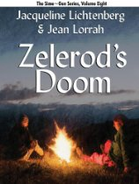
Zelerod’s Doom by Jacqueline Lichtenberg and Jean Lorrah. Book Eight.

Klyd Farris and Risa Tigue forge an alliance to reorganize both the Sime and Gen Territories, politically and economically. But both Territories have factions that are willing to battle each other, while the social fabric of their world falls apart. Will the mathematician, Zelerod’s prediction for humanity come to pass?
http://astore.amazon.com/simegen-20

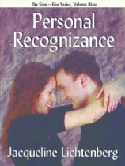
Personal Recognizance by Jacqueline Lichtenberg. Book Nine.
Vret McClintock, young channel in training at Rialite’s First Year Camp, stricken with Ilin Sumz, pursues her. Ilin runs the illicit historical fantasies board on the campus mainframe computer. Vret risks his career to extricate his love from her web of secrets before they can ruin the lives of everyone. http://astore.amazon.com/simegen-20

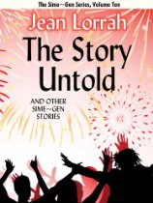
The Story Untold, and other Sime~Gen Stories by Jean Lorrah. Book Ten.
The tales of Tonyo Logan and Zhag Paget. Their music is the soundtrack of the turbulent period after the signing of the Unity Treaty, which mandates that Simes and Gens learn how to get along together! Will their world survive long enough for the pair to work their musical magic? http://astore.amazon.com/simegen-20

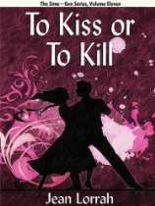
To Kiss or To Kill by Jean Lorrah. Book Eleven.
When Baird, Sime, rescues Jonmair, Gen, from the Last Kill, Jonmair suddenly has a life to live, and someone to share it with. Can Baird, a wealthy man in Norlea, also be the life partner that Jonmair longs for? Can love conquer all? Or will death finally triumph over love? http://astore.amazon.com/simegen-20

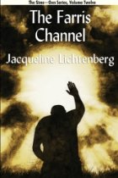
The Farris Channel Book Twelve.
The multi-generation saga, that began with Rimon Farris's story in First Channel, continued with the story of Rimon's son, Zeth Farris, in Channel's Destiny, now culminates with the story of how Zeth's son, Del Rimon Farris came to found the legendary House of Zeor. http://astore.amazon.com/simegen-20

