Jacqueline Lichtenberg

Molt Brother
E-BOOK EDITION
December 2005
www.wildsidepress.com www.fictionwise.com www.amazon.com –
trade paperback, mass market, e-book editions in multi-formats

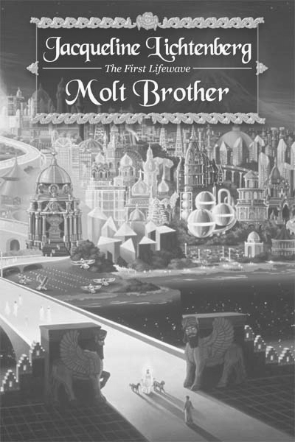

“. . .shows us a whole new approach, fresh and genuinely emotional, to interaction between human and alien.” -- Marion Zimmer Bradley

“Jacqueline Lichtenberg has taken a new and interesting direction with this book, partly technological, partly alien cultures, in a very intriguing interrelation.” – C. J. Cherryh

“Imaginative and outstanding. It captures the reader and won’t let go.” -- Andre Norton
“. . .suspenseful plot and intense characters make this a first-rate adventure. Recommended.” ------- Library Journal

“. . . can be savored as suspenseful adventure, with intensely developed and involved characters and a complex galactic milieu.” -------Fantasy Review

Bond Stronger Than Blood
College students, human and nonhuman, raised together on the same planet, search for the origins of civilization in the Galaxy and find old magic and a vast, implacable conspiracy.
Can they forge bonds of friendship and understanding among themselves strong enough to stand against greed, lust for power, and absolute domination of a hundred planets? If not, then why does the enemy fear them?

Read description and free samples

simegen.com/jl/kren/

