Jacqueline Lichtenberg

City of a Million Legends

Sequel to Molt Brother

E-BOOK EDITION

December 2005
www.wildsidepress.com www.fictionwise.com www.amazon.com –
trade paperback, mass market, e-book editions in multi-formats

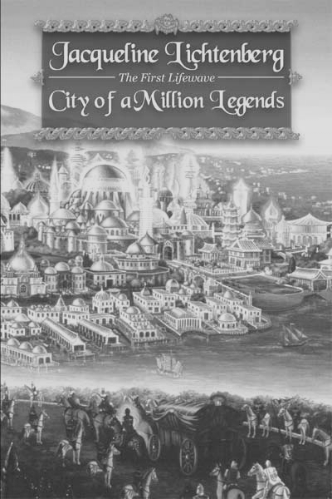
Reviews
“Molt Brother and City can both be savored as suspenseful adventure, with intensely developed and involved characters and a complex galactic milieu. City explores in some depth the mystic underpinnings of Lichtenberg’s First Lifewave, with the esoteric elements of past lives, psychic ability, and karmic ties. . . . Lichtenberg’s writing is top notch . . .”
Fantasy Review

“Marion Zimmer Bradley and Elizabeth Lynn are mistresses of the Care Book. . . . Jacqueline Lichtenberg . . . with Molt Brother and City of a Million Legends is . . . vying for the title. . . . Lichtenberg has actually combined another science fiction archetype with her Care Book . . . the hunt for the artifact of power – in this case, the City of a Million Legends where an extinct race once held the secret to ultimate power. . . . many well known authors have tried their hand at one (Care Book) – Robert Heinlein, Isaac Asimov, John Varley, Andre Norton among others. . . .” Baltimore Evening Sun

Reincarnated Galactic Priests
Older and wiser, the humans and nonhumans of Molt Brother now suffer the consequences of their actions. They have stirred the karma of their lifetimes lived billions of years ago – when they were responsible for the destruction of a Galactic Civilization, the First Lifewave.
Now they must seize the object of power that corrupted them the first time – to keep it from the hands of an implacable enemy.
Can they resist its lure and save the Second Lifewave?

Read description and free samples

simegen.com/jl/kren/

