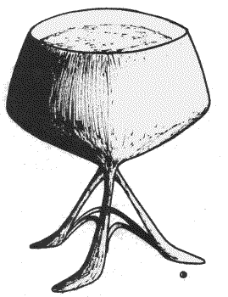

Created by Jacqueline Lichtenberg and 50 other contributors, this series of alternate universe Star Trek stories became legendary as the basis for research for Star Trek Lives!, the Bantam Paperback about why people loved Star Trek so much they couldn’t let it die.
ST:ToS stories by Claire Gabriel, a professional fiction writer who became fascinated with the relationships among the Enterprise crew – especially Amanda & Sarek, Spock’s birth and meeting with Kirk. She later wrote extensively about ST: Voyager
A Star Trek Inspirational Romance by Sharon Emily, Jean Lorrah, and many fanfic writers published before there were any Science Fiction/Futuristic Romances -- or supernatural Romance -- or vampire Romance, and even before the category of Inspirational Romance was recognized in the Romance field.
http://www.simegen.com/fandom/startrek/
Sime~Gen.com/fandom/startrek/

