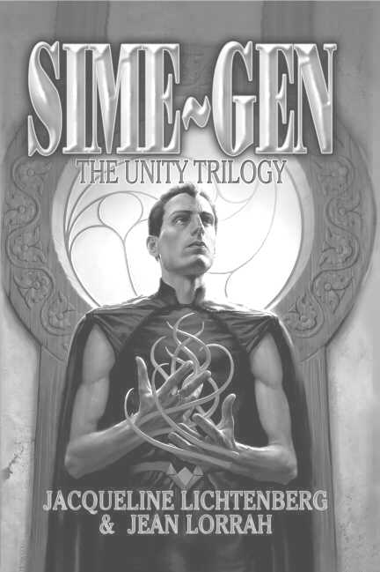

SIME~GEN: The Unity Trilogy*

By Jacqueline Lichtenberg and Jean Lorrah
Available NOW from Meisha Merlin Publishing, Inc.

Excerpt from Zelerod’s Doom…

Klyd flung himself onto the attacker, augmenting to pull the Simes apart. The junct dangled limply in his grasp.
Lenis fell, equally boneless. Klyd flung the junct aside and bent over Lenis. People were circling them now, channels on the outside of the ring, facing any other selyn-starved Simes who might show themselves.
Klyd drew Lenis into transfer position…but never touched his lips. He must have known it was hopeless from the moment he zlinned the kill. Emstead bent over them, demanding, “Help her! She was trying to protect me!”
The channel looked up. “It’s no use. She’s dead.”
“No,” Emstead choked. “Why did she do that! Why–?”
Ediva, meanwhile, was staring at what seemed to be unevenly packed snow. But it was only a thin layer, over…cloth…hair–
Risa returned to the center of the circle from zlinning the buildings around them. “He must have been the last,” she said as she bent over the Sime. “Now he’s dead too. I can’t zlin any more Simes, except the ones at the other end of the pass. So where is everybody?”
Ediva knelt beside a shape in the snow and gently broke away the encrusting ice.
Two figures emerged – two Simes locked together, tentacles twined in Sime/Sime transfer position, mute reminder of what they had just witnessed.
Ediva said, in a tight, frail voice, “They ran out of Gens during the storm. And of course, they couldn’t get out to hunt – so they turned on each other.”
She rose with the kind of calm that indicates deepest shock. Now they recognized the meaning of the shapes under the snow. Hundreds of such shapes.
She locked eyes with Emstead, who was as pale as the dead Sime at his feet. “Here–,” she said with the cruelty of unshielded fact, “–Zelerod’s Doom has already struck.”

*Sime~Gen: The Unity Trilogy Copyright © 2003 by Sime~Gen Inc.

