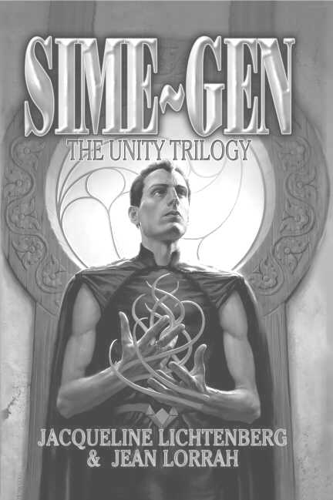

SIME~GEN: The Unity Trilogy*

By Jacqueline Lichtenberg and Jean Lorrah
Available NOW from Meisha Merlin Publishing, Inc.

Excerpt from Zelerod’s Doom…

Klyd flung himself onto the attacker, augmenting to pull the Simes apart. The junct dangled limply in his grasp.
Lenis fell, equally boneless. Klyd flung the junct aside and bent over Lenis. People were circling them now, channels on the outside of the ring, facing any other selyn-starved Simes who might show themselves.
Klyd drew Lenis into transfer position…but never touched his lips. He must have known it was hopeless from the moment he zlinned the kill. Emstead bent over them, demanding, “Help her! She was trying to protect me!”
The channel looked up. “It’s no use. She’s dead.”
“No,” Emstead choked. “Why did she do that! Why–?”
Ediva, meanwhile, was staring at what seemed to be unevenly packed snow. But it was only a thin layer, over…cloth…hair–
Risa returned to the center of the circle from zlinning the buildings around them. “He must have been the last,” she said as she bent over the Sime. “Now he’s dead too. I can’t zlin any more Simes, except the ones at the other end of the pass. So where is everybody?”
Ediva knelt beside a shape in the snow and gently broke away the encrusting ice.
Two figures emerged – two Simes locked together, tentacles twined in Sime/Sime transfer position, mute reminder of what they had just witnessed.
Ediva said, in a tight, frail voice, “They ran out of Gens during the storm. And of course, they couldn’t get out to hunt – so they turned on each other.”
She rose with the kind of calm that indicates deepest shock. Now they recognized the meaning of the shapes under the snow. Hundreds of such shapes.
She locked eyes with Emstead, who was as pale as the dead Sime at his feet. “Here–,” she said with the cruelty of unshielded fact, “–Zelerod’s Doom has already struck.”

*Sime~Gen: The Unity Trilogy Copyright © 2003 by Sime~Gen Inc.



Questions? Email us at: simegen@simegen.com
Sime~Gen Novels

By

Jacqueline Lichtenberg

& Jean Lorrah

The Unity Trilogy (2003)
Including:
House of Zeor
Ambrov Keon
Zelerod’s Doom

To Kiss or to Kill (2005)
Including:
To Kiss or to Kill
Best of Fools
Personal Recognizance

Forthcoming!

Fort Freedom
Including:
First Channel
Channel’s Destiny
Companions

The Farris Channel

Digen Farris Ambrov Zeor
Including:
Unto Zeor, Forever
Mahogany Trinrose
RenSime

Special Dispensation

"For many humans, the most unspeakable nightmare is the loss of the loneliness we feel when our impenetrable emotional barriers are pierced. Then suddenly we defend the loneliness we have railed against as if it were in fact our integrity -- as if we must choose between independence and love because others lack the compassion to handle our tender inner self. What if human nature changed? What if Nature declared a lack of compassion to be a capital offense?
"The Sime~Gen novels chronicle a Future History spanning more than 3,000 years where humans must learn compassion . . . or die."
The Sime~Gen Phenomenon

What is Sime~Gen?

www.simegen.com
Where Sime and Gen meet, Creativity Happens

- Discover what Sime~Gen is all about
- Find out more about Jacqueline Lichtenberg and Jean Lorrah
- Meet active Sime~Gen fans and join a discussion list (or two…or three)
- Discover the special gems of Sime~Gen fandom in the Rimon Farris Memorial Library
- Read and contribute to A Companion in Zeor - The Original Sime~Gen Fanzine, now entering its 26th year!
- Subscribe to the Lifeforce-L newsletter and get up-to-date news on upcoming novels and events
- Read free professional fiction by our Writers In Residence
- Read a Good Story, Do a Good Deed at the Sime Centre

Meisha Merlin:

Where the Past Meets the Future…
Over the next six years, all 8 original Sime~Gen novels will be reprinted in Meisha Merlin’s omnibus format - bound with new short fiction.

Between Omnibus editions there will be all new Sime~Gen novels by Jacqueline Lichtenberg or Jean Lorrah.
*Artwork created by Patric Michael © 2004
*Flyer designed by Jana Paniccia

