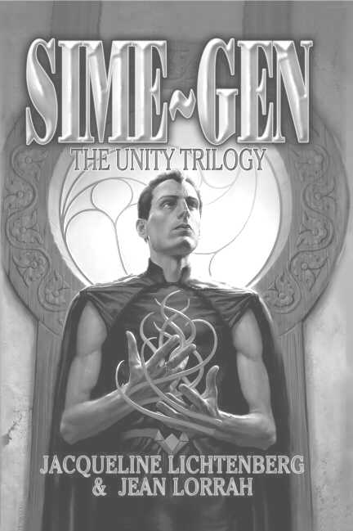

SIME~GEN: The Unity Trilogy*

By Jacqueline Lichtenberg and Jean Lorrah
Available NOW from Meisha Merlin Publishing, Inc.

Excerpt from House of Zeor…

Valleroy breasted the wave of frigid air and plunged across the deserted court. Halfway to his goal, he heard a faint tapping sound. He stopped in his tracks, holding his breath. There was no wind to stir tree branches. But the tapping came again, hardly more than a flutter.
Head cocked in concentration, Valleroy moved a few steps toward the outer wall and paused. Again it came, louder now. He moved toward the small postern gate at the left of the big gates. Again that pattering knock, but this time he detected deliberate urgency behind it, as if the knocker now perceived someone coming.
Propping his folio against the wall, Valleroy lifted the formidable bar that secured the outside door against Berserkers or Sime Raiders. Then he yanked the door open, half afraid of what he’d find there.
The bloody scarecrow that staggered into his arms was less shocking that the scenes he’d imagined. Valleroy eased the limp figure onto the cobblestones, almost losing his grip in the slippery blood. Around the man’s waist coiled one of the Sime Raider’s whips complete with inlaid handle. It seemed to Valleroy a grotesque contrast to the tattered, Zeor-blue coverall.
The man’s face and torso were covered with hundreds of lacerations, as if he’d tumbled down a gravel embankment. But, Valleroy saw, most of the blood was coming from his forearms. He peeled back the sleeves to find deeply slashed tentacle sheaths from which the blood spurted rhythmically, but not as profusely as it had. It slowed visibly as Valleroy watched.
“I’ll get Sectuib Farris,” said Valleroy in his most assuring voice, though he knew this man wouldn’t see another dawn.
“Stay Naztehr!” husked the Sime, marshalling all his strength.
Valleroy paused, transfixed by an odd thrill at the man’s use of the most intimate Householding term of membership…the one thing he’d never been called before. He had to bend close to hear the faint whisper of dying breath. “Tell Klyd…Hrel spies for Andle…Aisha…with Runzi…”

*Sime~Gen: The Unity Trilogy Copyright © 2003 by Sime~Gen Inc.



Questions? Email us at: simegen@simegen.com
Sime~Gen Novels

By

Jacqueline Lichtenberg

& Jean Lorrah

The Unity Trilogy (2003)
Including:
House of Zeor
Ambrov Keon
Zelerod’s Doom

To Kiss or to Kill (2005)
Including:
To Kiss or to Kill
Best of Fools
Personal Recognizance

Forthcoming!

Fort Freedom
Including:
First Channel
Channel’s Destiny
Companions

The Farris Channel

Digen Farris Ambrov Zeor
Including:
Unto Zeor, Forever
Mahogany Trinrose
RenSime

Special Dispensation

"For many humans, the most unspeakable nightmare is the loss of the loneliness we feel when our impenetrable emotional barriers are pierced. Then suddenly we defend the loneliness we have railed against as if it were in fact our integrity -- as if we must choose between independence and love because others lack the compassion to handle our tender inner self. What if human nature changed? What if Nature declared a lack of compassion to be a capital offense?
"The Sime~Gen novels chronicle a Future History spanning more than 3,000 years where humans must learn compassion . . . or die."
The Sime~Gen Phenomena

What is Sime ~Gen?

www.simegen.com
Where Sime and Gen meet, Creativity Happens

- Discover what Sime~Gen is all about
- Find out more about Jacqueline Lichtenberg and Jean Lorrah
- Meet active Sime~Gen fans and join a discussion list (or two…or three)
- Discover the special gems of Sime~Gen fandom in the Rimon Farris Memorial Library
- Read and contribute to A Companion in Zeor - The Original Sime~Gen Fanzine, now entering its 26th year!
- Subscribe to the Lifeforce-L newsletter and get up-to-date news on upcoming novels and events
- Read free professional fiction by our Writers In Residence
- Read a Good Story, Do a Good Deed at the Sime Centre

Meisha Merlin:

Where the Past Meets the Future…
Over the next six years, all 8 original Sime~Gen novels will be reprinted in Meisha Merlin’s omnibus format - bound with new short fiction.

Between Omnibus editions there will be all new Sime~Gen novels by Jacqueline Lichtenberg or Jean Lorrah.
*Artwork created by Patric Michael © 2004
**Flyer designed by Jana Paniccia

