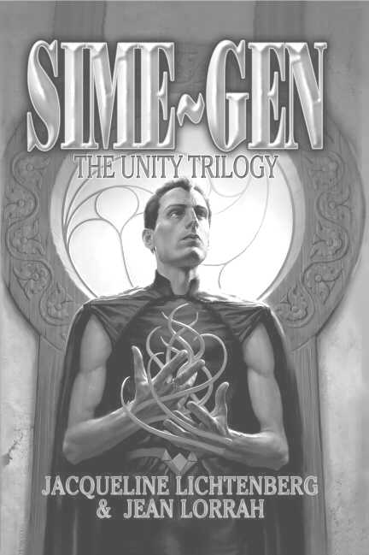

SIME~GEN: The Unity Trilogy*

By Jacqueline Lichtenberg and Jean Lorrah
Available NOW from Meisha Merlin Publishing, Inc.

Excerpt from Ambrov Keon…

The high field of the Gen in the shrine washed over Risa, easing her need with promise. There was no fear in it – he must not know that she was there.
Basking in his field, she became duoconscious – both her Sime senses and her other senses operating at once. She could see him silhouetted against the fire. Too large for a recently established adolescent. A full-grown Gen.
What was he doing here? Blown into Sime Territory by the storm? It didn’t matter; he was life to her. The moment he knew she was there, that tempting field would erupt with the fear she needed as much as his selyn. She would drain him, charging her aching nerves – surely that incredible field promised that for once she would be fully satisfied–
She took a step forward, just as the Gen said, “Why don’t you come over to the fire and get warm?”
It was Risa who flared fear. Then she wondered what kind of fool believed only a Gen could enter the shrine.
The Gen leaned forward to poke up the fire, then stood – and she saw that he was huge. Gens were usually bigger than Simes, but this was the biggest one she’d ever seen – the absurd thought crossed her mind that his size meant he stored more selyn, although she knew the two things were unrelated.
He was turning toward her now. She moved forward, waiting for him to recognize a Sime in need, yearning for the fear that would charge his field for her kill. Her laterals dripped ronaplin in expectation. She moved forward step by step, savoring his field, waiting for the moment of recognition, of terror – the peak bliss of the kill!

*Sime~Gen: The Unity Trilogy Copyright © 2003 by Sime~Gen Inc.



Questions? Email us at: simegen@simegen.com
Sime~Gen Novels

By

Jacqueline Lichtenberg

& Jean Lorrah

The Unity Trilogy (2003)
Including:
House of Zeor
Ambrov Keon
Zelerod’s Doom

To Kiss or to Kill (2005)
Including:
To Kiss or to Kill
Best of Fools
Personal Recognizance

Forthcoming!

Fort Freedom
Including:
First Channel
Channel’s Destiny
Companions

The Farris Channel

Digen Farris Ambrov Zeor
Including:
Unto Zeor, Forever
Mahogany Trinrose
RenSime

Special Dispensation

"For many humans, the most unspeakable nightmare is the loss of the loneliness we feel when our impenetrable emotional barriers are pierced. Then suddenly we defend the loneliness we have railed against as if it were in fact our integrity -- as if we must choose between independence and love because others lack the compassion to handle our tender inner self. What if human nature changed? What if Nature declared a lack of compassion to be a capital offense?
"The Sime~Gen novels chronicle a Future History spanning more than 3,000 years where humans must learn compassion . . . or die."
The Sime~Gen Phenomenon

What is Sime~Gen?

www.simegen.com
Where Sime and Gen meet, Creativity Happens

- Discover what Sime~Gen is all about
- Find out more about Jacqueline Lichtenberg and Jean Lorrah
- Meet active Sime~Gen fans and join a discussion list (or two…or three)
- Discover the special gems of Sime~Gen fandom in the Rimon Farris Memorial Library
- Read and contribute to A Companion in Zeor - The Original Sime~Gen Fanzine, now entering its 26th year!
- Subscribe to the Lifeforce-L newsletter and get up-to-date news on upcoming novels and events
- Read free professional fiction by our Writers In Residence
- Read a Good Story, Do a Good Deed at the Sime Centre

Meisha Merlin:

Where the Past Meets the Future…
Over the next six years, all 8 original Sime~Gen novels will be reprinted in Meisha Merlin’s omnibus format - bound with new short fiction.

Between Omnibus editions there will be all new Sime~Gen novels by Jacqueline Lichtenberg or Jean Lorrah.
*Artwork created by Patric Michael © 2004
*Flyer designed by Jana Paniccia

