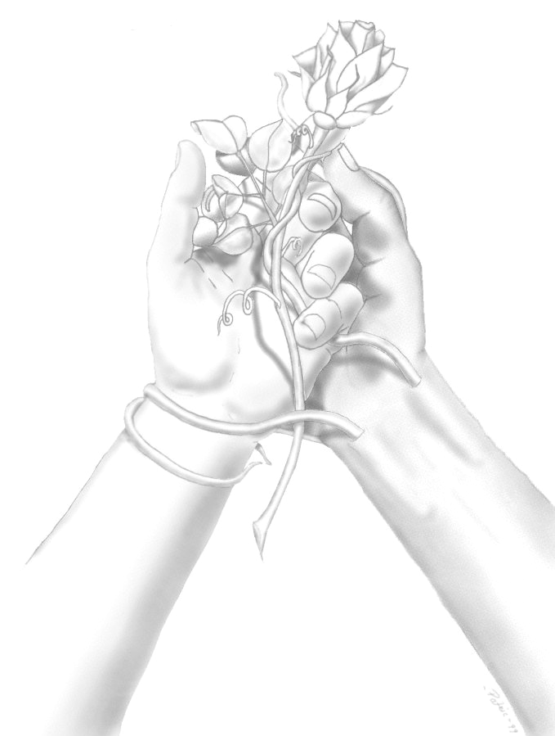

Sime~Gen Novels

By

Jacqueline Lichtenberg

& Jean Lorrah

The Unity Trilogy (2003)
Including:
House of Zeor
Ambrov Keon
Zelerod’s Doom

To Kiss or to Kill (2005)
Including:
To Kiss or to Kill
Best of Fools
Personal Recognizance

Forthcoming!

Fort Freedom
Including:
First Channel
Channel’s Destiny
Companions

The Farris Channel

Digen Farris Ambrov Zeor
Including:
Unto Zeor, Forever
Mahogany Trinrose
RenSime

Special Dispensation

"For many humans, the most unspeakable nightmare is the loss of the loneliness we feel when our impenetrable emotional barriers are pierced. Then suddenly we defend the loneliness we have railed against as if it were in fact our integrity -- as if we must choose between independence and love because others lack the compassion to handle our tender inner self. What if human nature changed? What if Nature declared a lack of compassion to be a capital offense?
"The Sime~Gen novels chronicle a Future History spanning more than 3,000 years where humans must learn compassion . . . or die."
The Sime~Gen Phenomenon

What is Sime~Gen?

www.simegen.com
Where Sime and Gen meet, Creativity Happens

- Discover what Sime~Gen is all about
- Find out more about Jacqueline Lichtenberg and Jean Lorrah
- Meet active Sime~Gen fans and join a discussion list (or two…or three)
- Discover the special gems of Sime~Gen fandom in the Rimon Farris Memorial Library
- Read and contribute to A Companion in Zeor - The Original Sime~Gen Fanzine, now entering its 26th year!
- Subscribe to the Lifeforce-L newsletter and get up-to-date news on upcoming novels and events
- Read free professional fiction by our Writers In Residence
- Read a Good Story, Do a Good Deed at the Sime Centre

Meisha Merlin:

Where the Past Meets the Future…
Over the next six years, all 8 original Sime~Gen novels will be reprinted in Meisha Merlin’s omnibus format - bound with new short fiction.

Between Omnibus editions there will be all new Sime~Gen novels by Jacqueline Lichtenberg or Jean Lorrah.

*Artwork created by Patric Michael © 2004
*Flyer created by Jana Paniccia

