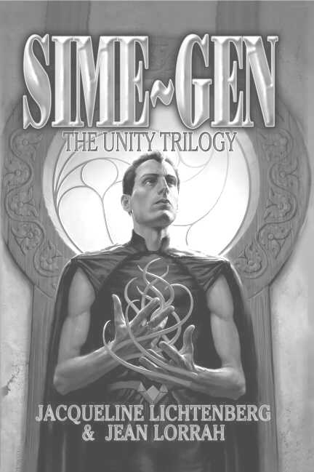

SIME~GEN: The Unity Trilogy*

By Jacqueline Lichtenberg and Jean Lorrah
Available NOW from Meisha Merlin Publishing, Inc.

Excerpt from House of Zeor…

Valleroy breasted the wave of frigid air and plunged across the deserted court. Halfway to his goal, he heard a faint tapping sound. He stopped in his tracks, holding his breath. There was no wind to stir tree branches. But the tapping came again, hardly more than a flutter.
Head cocked in concentration, Valleroy moved a few steps toward the outer wall and paused. Again it came, louder now. He moved toward the small postern gate at the left of the big gates. Again that pattering knock, but this time he detected deliberate urgency behind it, as if the knocker now perceived someone coming.
Propping his folio against the wall, Valleroy lifted the formidable bar that secured the outside door against Berserkers or Sime Raiders. Then he yanked the door open, half afraid of what he’d find there.
The bloody scarecrow that staggered into his arms was less shocking that the scenes he’d imagined. Valleroy eased the limp figure onto the cobblestones, almost losing his grip in the slippery blood. Around the man’s waist coiled one of the Sime Raider’s whips complete with inlaid handle. It seemed to Valleroy a grotesque contrast to the tattered, Zeor-blue coverall.
The man’s face and torso were covered with hundreds of lacerations, as if he’d tumbled down a gravel embankment. But, Valleroy saw, most of the blood was coming from his forearms. He peeled back the sleeves to find deeply slashed tentacle sheaths from which the blood spurted rhythmically, but not as profusely as it had. It slowed visibly as Valleroy watched.
“I’ll get Sectuib Farris,” said Valleroy in his most assuring voice, though he knew this man wouldn’t see another dawn.
“Stay Naztehr!” husked the Sime, marshalling all his strength.
Valleroy paused, transfixed by an odd thrill at the man’s use of the most intimate Householding term of membership…the one thing he’d never been called before. He had to bend close to hear the faint whisper of dying breath. “Tell Klyd…Hrel spies for Andle…Aisha…with Runzi…”

*Sime~Gen: The Unity Trilogy Copyright © 2003 by Sime~Gen Inc.

